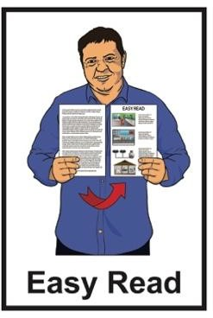

Information about measles

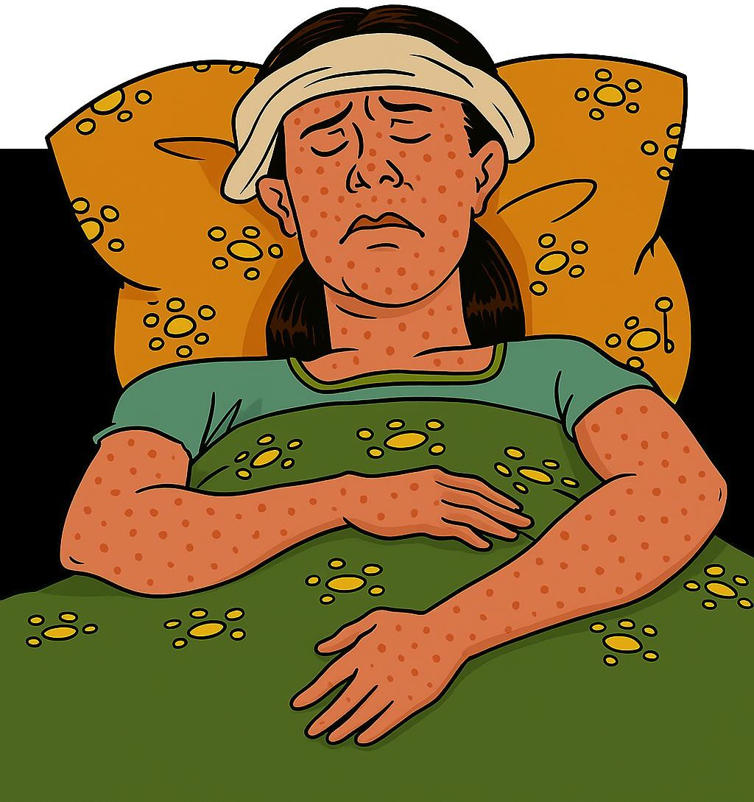

Published: September 2025

Before you start

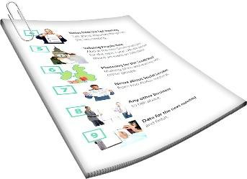
This is a long document.

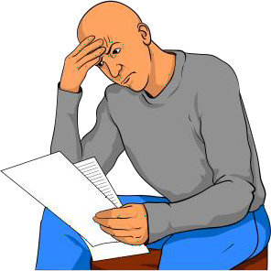
It can be hard for some people to read a document this long.

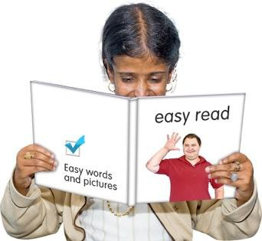
Some things you can do to make it easier are:

- read it a few pages at a time

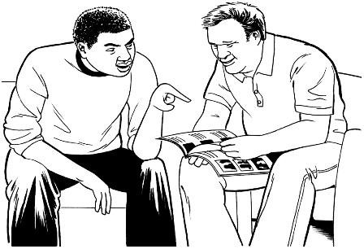
- set aside some quiet time to look at it

- have someone read it with you to support you to understand it.

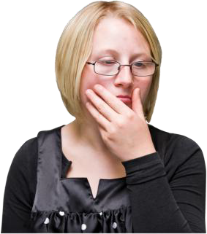
Some of the information in this document may make people:

- upset

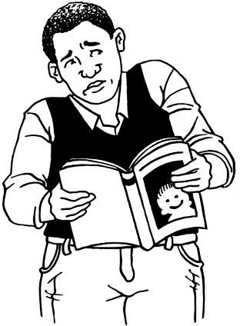
- worried.

This information is not meant to scare anyone.


This information does not mean the things in this document will happen to:

- you

- people you know.

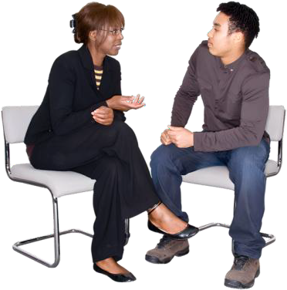
If you are worried you can talk to your:

- whānau / family

- friends

- doctor.

What is in this document

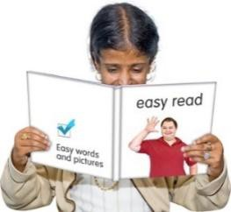
Page number:

What this document is about 5

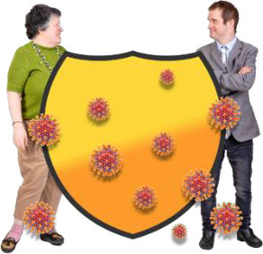
What is measles? 6

Being immune to measles 7

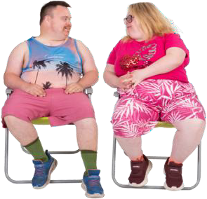
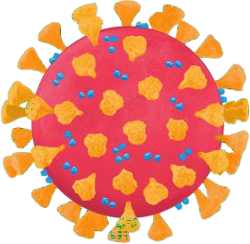
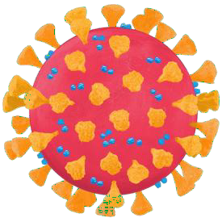
What measles does to your body 11

How measles spreads 14

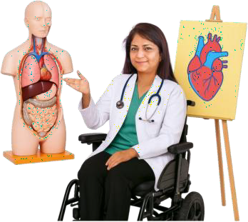
Getting sicker because
of measles 16

Page number:

Keeping safe from measles 19

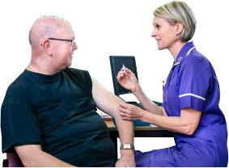
Who can get the MMR vaccine 22

How to get the MMR vaccine 25

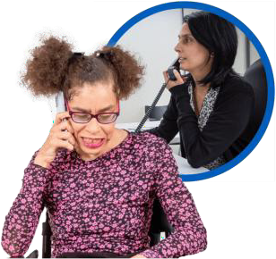
What to do if you think you
have measles 21

What to do if you are in contact
with someone with measles 29


What to do if you have measles 36

More information 38

What this document is about

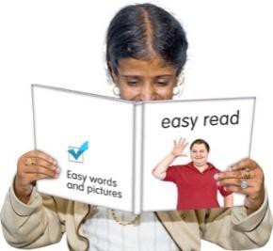
This Easy Read tells you the things you need to know about measles.

Measles is an illness that can:
•
make you very sick
•
be caught by:
- adults
- children.

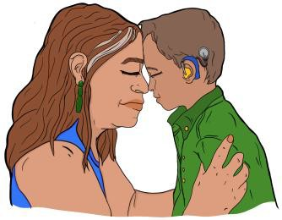
This document is by
Health New Zealand – Te Whatu Ora.

What is measles?

Measles is an illness that can spread between people very easily.

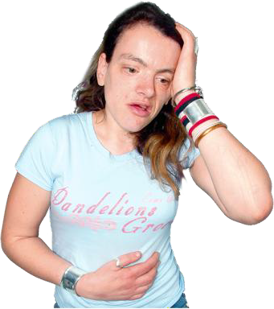
It can:

- make you feel very sick

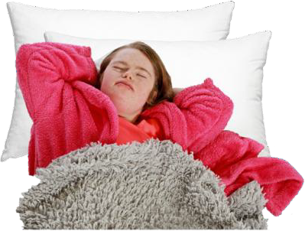
- cause you to have other health problems that last a long time after the measles has gone

- make it more likely for you to get other illnesses.

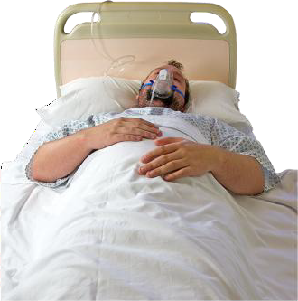
Measles can make someone sick enough that:

- they might need to go to hospital

- they might die.

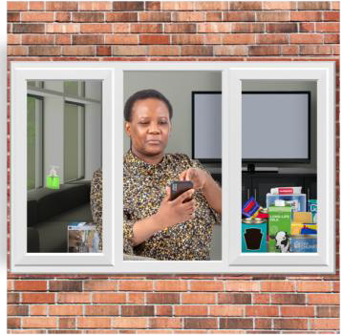
Being immune to measles

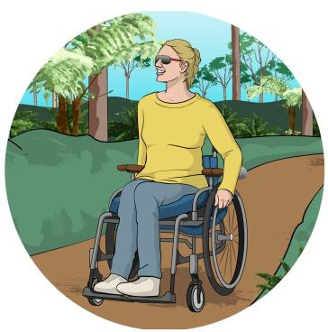
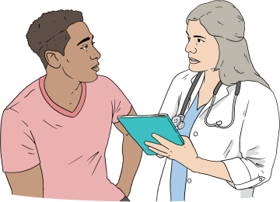
It is important to check if you are immune to measles.
Being immune to measles means
you:
•
cannot get measles
•
cannot pass measles to
someone else
•
do not need to stay at home / quarantine if you are a close contact of someone with
measles.

To quarantine means you need to:
•
stay at home
•
keep away from other people.
A close contact is someone who has been near someone with measles.

You are immune to measles if:

- you have had measles before

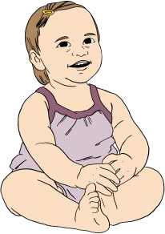
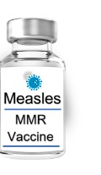
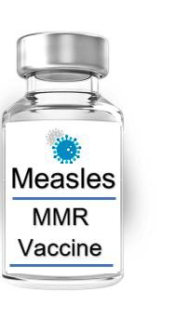
or

- you have had 2 measles vaccines after the age of 1 year.

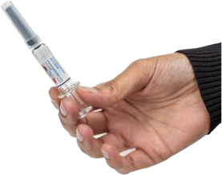
A measles vaccine is an injection that stops you from getting measles.

In Aotearoa New Zealand the measle vaccine is 1 that also protects you against 2 other illnesses called:

- mumps


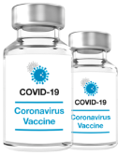
- rubella / German measles.

Getting the vaccine is the best way to protect everyone against measles.

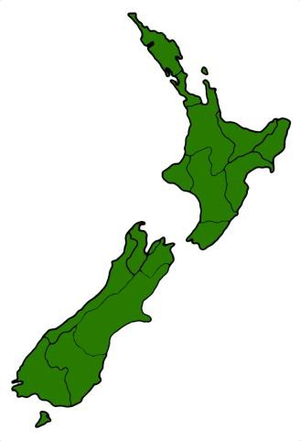
You are likely to be immune to measles if before 1969 you were:

- born in New Zealand before 1969

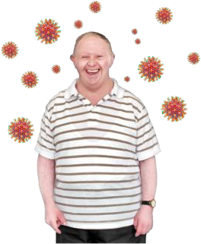
- living in New Zealand before 1969.

This is because almost everyone caught measles before 1969.

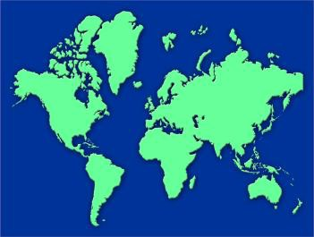
If you lived in a different country before 1969 you should check with your doctor / healthcare provider if you are immune to measles.

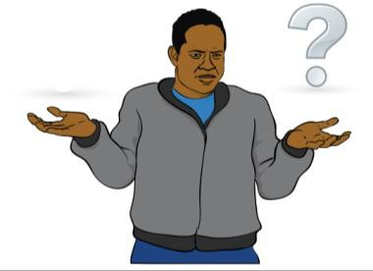
You should get the vaccine if you are:

- not immune to measles

- not sure if you are immune to measles.


To find out more about checking your immunity go to:

https://info.health.nz/measles-immunity

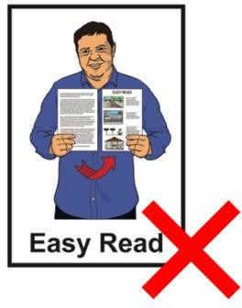
This website is not in Easy Read.

What measles does to your body

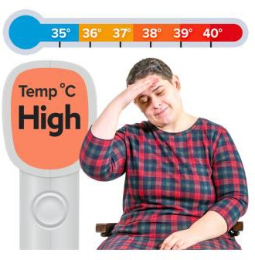
When you first get measles you may feel like you have another illness like the flu.

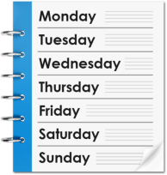
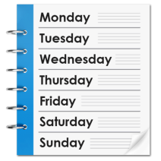
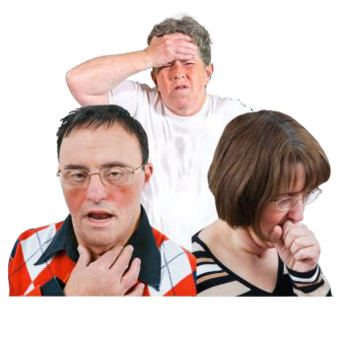
Symptoms of measles can start between 1 week to 3 weeks after you have been near someone with measles.

Symptoms are the things that happen which tell you that you may
be sick.

People with measles may have these symptoms:

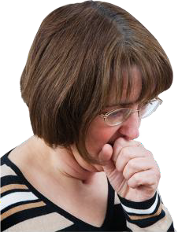
- a fever which means you feel very hot

- a cough

- a runny nose

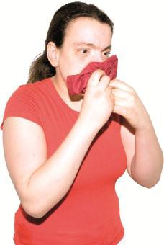
- eyes that are:

  - sore

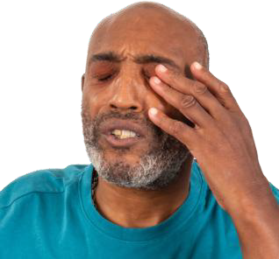
  - watery

  - pink.

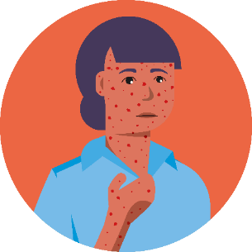
You will normally get a rash 3 to 7 days after the other symptoms start.

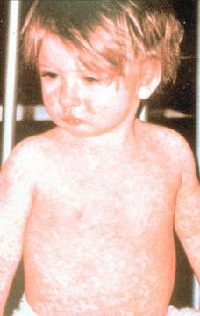
A rash is when parts of your skin
become:
•
red
•
itchy.

The rash starts on your face / neck before spreading to the rest of your body.

How measles spreads

Measles is spread between people by a person with measles:

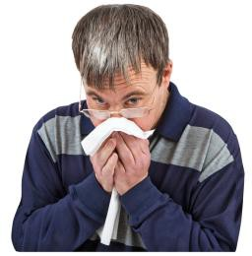
- breathing near others

- sneezing near others

- coughing near others

- talking near others.

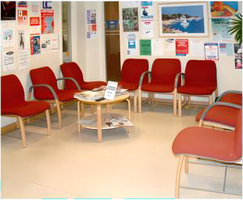
You can catch measles by going into a room after someone with measles has been in the room.

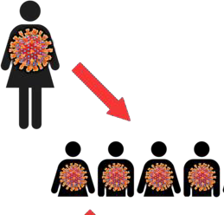
1 person with measles can spread it to a lot of other people.

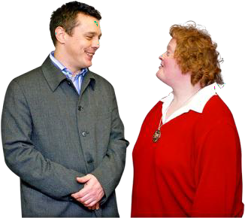
You can also catch measles from someone before they know they have measles.

This can happen from:

- 4 days before they get the rash

until

- 4 days after they get the rash.

Getting sicker because of measles

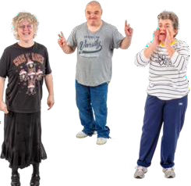
About 1 out of every 3 people with measles will be so sick they will need to go to hospital.


There are some people who are more likely to get very sick if they get measles like:

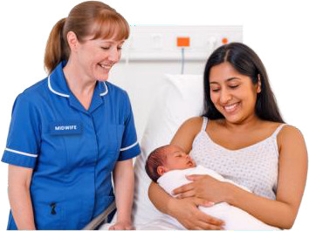
- babies and children who are under 5 years old

- people who have had a baby in the last 6 weeks

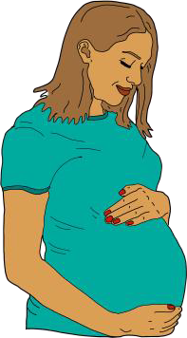
- pregnant people

- anyone with a weakened immune system.

A weakened immune system
means you:
•
get sick easily
•
have a hard time getting better
when you are sick.

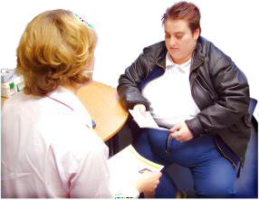
A weakened immune system can be caused by:

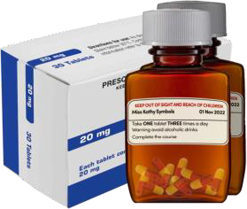
- different health conditions

- medication.

Check with your doctor if you are worried you may have a weakened immune system.

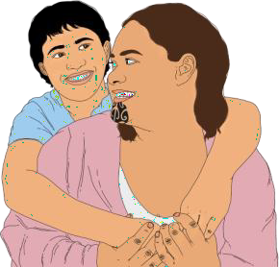
Other groups of people more likely to be sent to hospital because of the measles are:

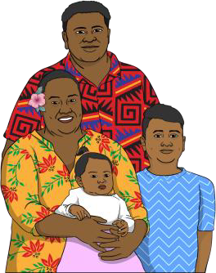
- Māori people

- Pacific peoples.

Keeping safe from measles

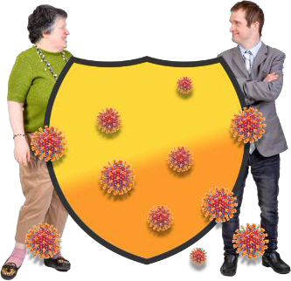
Getting the Measles Mumps Rubella / MMR vaccine means you are less likely to:

- get measles

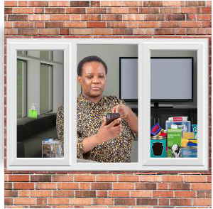
- spread measles

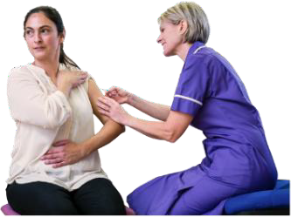
- need to stay home if you are in contact with someone with measles.
The Measles Mumps Rubella / MMR vaccine is an injection that can protect you from getting measles.

You need to get the MMR vaccine
2 times.

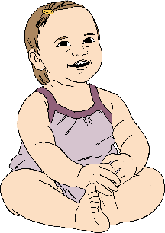
Babies usually get their MMR vaccine at:

- 12 months old

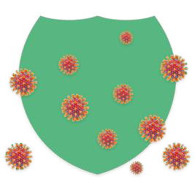
- 15 months old.

Getting your baby the vaccine on time is the best way to keep them safe from measles.

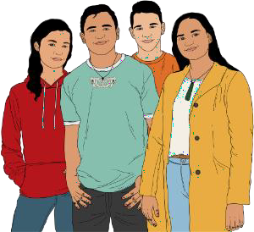
The MMR vaccine does not cost money for:

- everyone under 18 years old

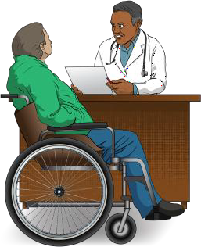
- people 18 years old and over if they have access to free New Zealand healthcare.

Information on free healthcare in New Zealand is available at this website:

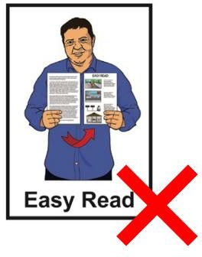
tinyurl.com/y6s7khma

This information is not in Easy Read.

More information about the MMR vaccine is available at this website:

tinyurl.com/yvkjvhny

This information is not in Easy Read.

Who can get the MMR vaccine

Most people can get the MMR vaccine.

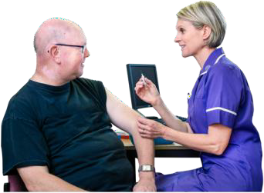
It is safe to get more than 2 doses of the vaccine.

It is best to get another vaccine if you do not know if you have had 2 MMR vaccine doses.

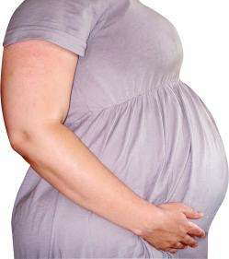
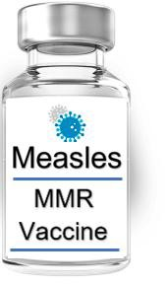
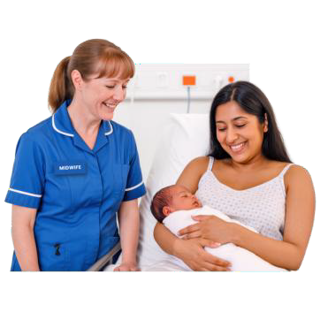
You cannot have the vaccine if you are pregnant.

You can have the vaccine after you give birth.

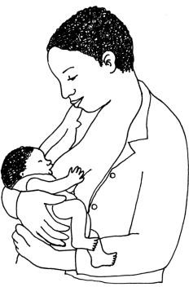
The vaccine is safe to have if you are breastfeeding.

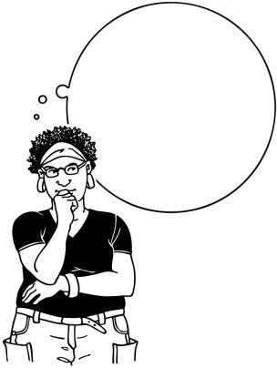
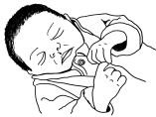
It is important to have had 2 doses of the MMR vaccine if you are planning a pregnancy.

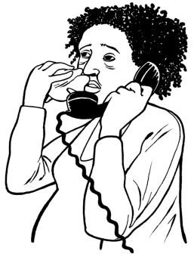
If you catch measles during pregnancy it can harm:

- you

- your baby.

Some people with weakened immune systems cannot have the MMR vaccine.

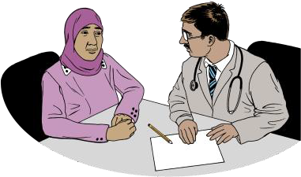
If you have a health condition that weakens your immune system talk to your doctor to see if you can have the vaccine.

How to get the MMR vaccine

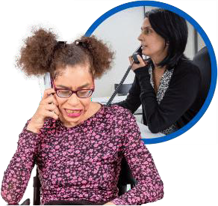
To get your MMR vaccine make an appointment with your:

- family doctor / GP

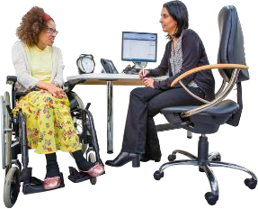
- hauora provider

- healthcare provider.


Some pharmacies can give MMR vaccines.

A list of pharmacies that give MMR vaccines is available at this website:

tinyurl.com/2vra2tky

This website is not in Easy Read.

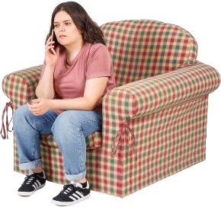
You can also book an appointment to get the MMR vaccine:

- by calling the Vaccination Helpline on:

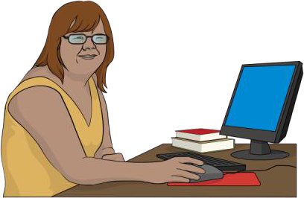
0800 28 29 26

- online at:

app.bookmyvaccine.health.nz


Calling the Vaccination Helpline does
not cost money.

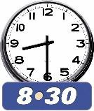
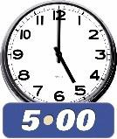
The Vaccination Helpline is open:

- 8.30 am to 5 pm

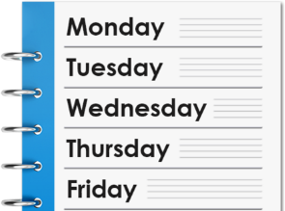
- Monday to Friday.

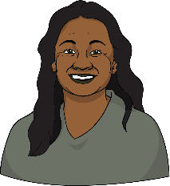
You can also choose to speak with a:

- Māori advisor

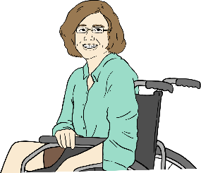
- Pacific advisor

- disability advisor.

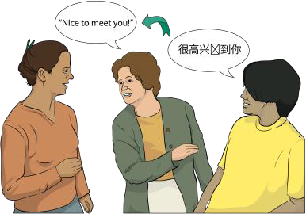
The Vaccination Helpline has interpreters available if you do not speak English as your first language.

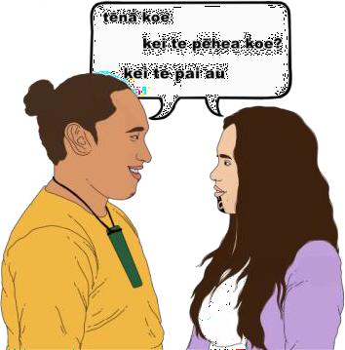
Here interpreters are people who:
•
speak more than 1 language
•
explain what is being said by both people in languages they
can understand.


If you find it hard to use the phone the New Zealand Relay service is for people who are:

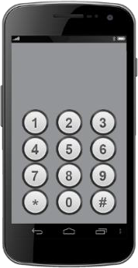
- Deaf / hard of hearing

- deafblind

- speech impaired / find it hard to talk.

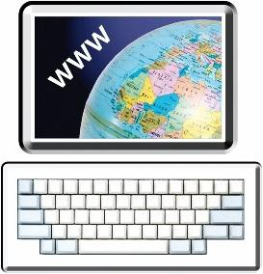
You can find out more about the New Zealand Relay service at:

www.nzrelay.co.nz

What to do if you think you have measles

If you think you / a family member has measles you should call your:

- family doctor / GP

- hauora provider

- healthcare provider.

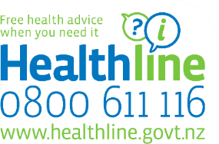
You can also call Healthline on:

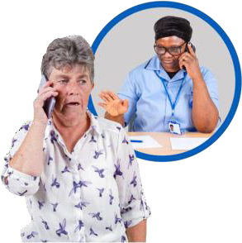
0800 611 116

You can call Healthline:

- for free health advice

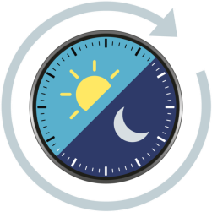
- about what to do next

- at anytime


It does not cost any money to call Healthline.

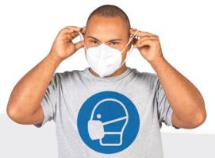
If you need to go somewhere to get healthcare you must:

- wear a mask that covers your:

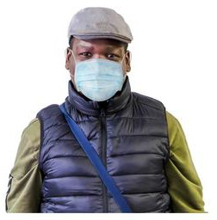
  - nose and
  - mouth

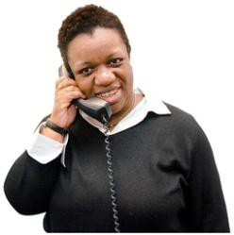
- call first to say you:

  - think you have measles

or

  - have been near someone with measles.

What to do if you are in contact with someone with measles

What you need to do if you are in contact with someone with measles is different if you are:

- not immune to measles

- partially vaccinated which means you have only had 1 dose of the MMR vaccine

- immune to measles.

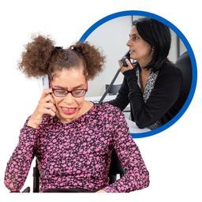
Your local public health service will contact you to:

- support you

- tell you what you need to do next.

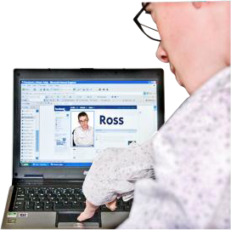
Your local public health service:

- will check your health records

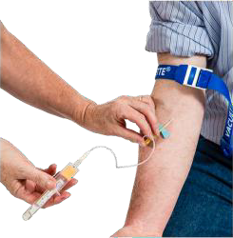
- may ask you to get a blood test to check if you are immune to measles.

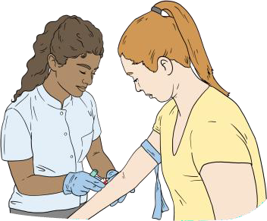
A blood test is when a healthcare worker uses a needle to take some of your blood to be tested.

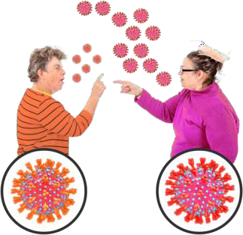
If you are not immune you have a chance of spreading measles to other people.

You need to quarantine if you are not immune.

If you have had 1 dose of MMR vaccine you should stay away:

- people who are likely to get very sick if they get measles

- places measles could spread easily like:

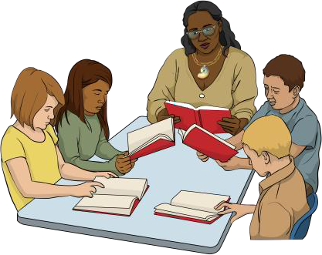
  - early learning services like kindy / daycare

  - schools

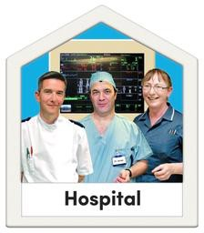
  - healthcare
facilities like hospitals.

If you have had 1 dose of MMR vaccine you also need to keep checking for any measles symptoms.

If you get measles symptoms it means you may have measles.

It is very important if you get measles symptoms to:

- stay home

- get health advice.

If you are immune you are not likely to:

- have measles symptoms

- get measles

- spread measles.


This means that if you are feeling well you can continue to do things like:

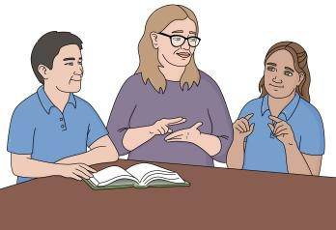
- go to work

- go to school.

If you do get measles symptoms it is very important to:

- stay home

- get health advice.

What to do if you have measles

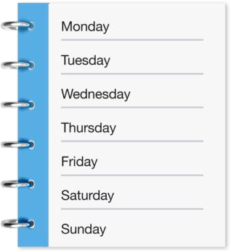
If you have measles you will need to quarantine / stay at home until 4 days after the rash started.
Rash started

This stops you spreading measles to other people.

Your local public health service will contact you to:

- check on you

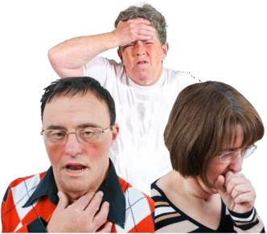
- check what your symptoms are

- make sure you know what to do if your symptoms get worse.

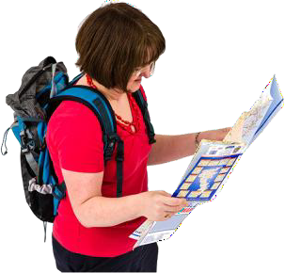
Your local public health service will also ask you:

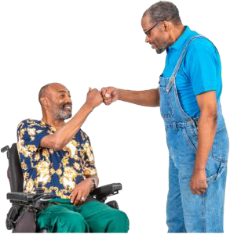
- where you went when you were able to spread measles

- who you spent time with when you were able to spread measles.

It is important to tell them this because other people may have caught measles from you.

More information

You can find out more about measles on our website:

tinyurl.com/yc5tkswe

Some information on our website is
not in Easy Read.

You can also call Healthline on:

0800 611 116

You can call Healthline:

- anytime

- for free.

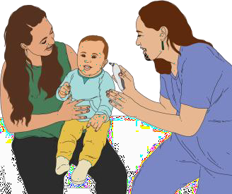
If you want to talk to a Māori healthcare professional you can call Healthline:

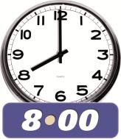
- any day

- 8 am to 8 pm.
.

You can contact the Disability Helpline for more information for disabled people by:

- calling:

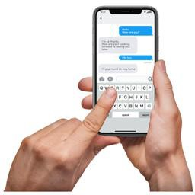
0800 11 12 13

- texting:

8988.

The Disability Helpline is available:

- Monday to Friday

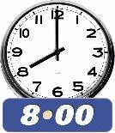
- 8.30 am to 5 pm.

More information about the Disability Helpline is available here:

tinyurl.com/aumxzsax

This information is not in Easy Read.

People living in rural areas can contact a doctor at Ka Ora Telecare:

- by calling:

0800 252 672
- on their website: tinyurl.com/2yw4cfmy

Ka Ora Telecare is available:

- after hours:

  - from 5 pm to 8.30 am

  - on Monday to Friday

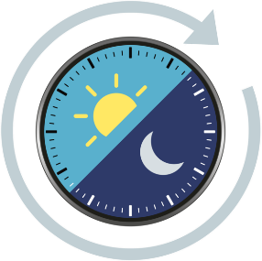
- 24 hours / all the time on

  - weekends

  - public holidays.

If you find it hard to use the phone the New Zealand Relay service is for people who are:

- Deaf / hard of hearing

- deafblind

- speech impaired / find it hard to talk.

You can find out more about the New Zealand Relay service at:

www.nzrelay.co.nz




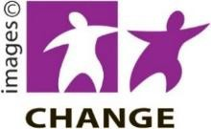




This information has been written by Health New Zealand – Te Whatu Ora

It has been translated into Easy Read by the Make it Easy Kia Māmā Mai service of People First New Zealand Ngā Tāngata Tuatahi.

The ideas in this document are not the ideas of
People First New Zealand Ngā Tāngata Tuatahi.

All images used in this Easy Read document are subject to copyright rules and cannot be used without permission.

Make it Easy uses images from:

- Photosymbols
- Change Images
- Huriana Kopeke-Te Aho
- SGC Image Works
- T Wood
- Studio Rebeko
- Inga Kramer.

